SDV602 ASsessment 1

Portfolio Project 1 – Scene to Scene Game Design And Analysis

Alex Herbert

27/07/2024

## Game Concept

This project is based on designing and implementing a scene-to-scene text-based game using the python programming language, typically these games follow a multiple path story line that allows the player to make choices that effect the progress of the story and contain challenges specific to the path the player chooses.

**Game Title**: Legend of the Sacred Forest

**Theme**

The game is set in a mystical land filled with enchanted forests, ancient temples, and mythical creatures. The player takes on the role of a hero destined to save the kingdom by finding the Sacred Relics and defeating the evil sorcerer.

**Initial Story Line**

You are Aelion, a young hero chosen by the ancient spirits to embark on a quest to save the Kingdom of Eldoria from an evil sorcerer called Malakar. Malakar has cast a dark spell over the land, and only by finding the Sacred Relics hidden in various hidden temples can you hope to defeat him and restore peace to the land. Armed with the legendary sword Arundil and trusty shield, you set out on an epic journey of danger and mystery.

**Key Elements**

**Scenes**

* **Village of Arion:** The starting point of the game where the player receives their first quest and introduction to the game and story line.
* **Whispering Forest:** A dense, enchanted forest filled with secrets and dangerous creatures.
* **Temple of Ages:** An ancient temple where time seems to stand still when entered, this temple seems untouched by ageing and natural deterioration.
* **Shadow Cavern:** A dark and gloomy cave filled with ancient traps and dark monsters.
* **Fountain of Serenity:** A magical fountain that is intertwined with the roots of the elder tree, this place is the heart of the forest.
* **Blaze Temple:** This temple is built into the depths of a volcano, extremely dangerous and requires specific equipment to be able to enter.
* **Aqua Temple:** A temple submerged with water the flows from the heart of the mountains. Contains aquatic beasts and water-based puzzles.
* **Malakar’s Fortress:** The final stronghold of the evil sorcerer Malakar, this will be the final location and will require all the Sacred Relics to be collected before entering.

**Monsters**

* **Gremlins:** Mischievous creatures that attack in groups, these are found in the Shadow Cavern location.
* **Nightwings:** A Bat-like creature that swoops down on its target, these are found in the Whispering Forest location.
* **Boneguards:** Skeleton Warriors that guard the ancient Temple of Ages, these are warriors that have pledged to protect the Temple, even after death.
* **Night Riders:** Powerful armoured knights that are loyal to Malakar, these riders will hunt on the roads in between locations and generally ride solo.
* **Flame Elemental:** These are conjured elemental spirits that embody the fire element, these are found at the Blaze Temple in the volcano.
* **Dark Shark:** Predatory shark-type creatures that have been cursed with dark magic, they are found at the Aqua Temple location.
* **Malakar:** The final boss who wields dark magic and commands all the forces of evil that have been unleashed on the Kingdom of Eldoria.

**Inventory Items**

* **Healing Elixir:** Restores health to the player when consumed.
* **Explosive Orbs:** Magical Orbs that explode to destroy obstacles or enemies.
* **Mystic Arrows:** Magical Arrows that can reach flying enemies or hard to reach obstacles.
* **Sacred Relics:** Key items needed to unlock the path to Malakars Fortress.
* **Defender Shield:** Blocks enemy attacks and certain environmental hazards.
* **Heart Shards:** These can be collected to increase the total health pool of the character.
* **Gillyweed:** Allows the player to breath underwater for a sustained period.
* **Ice Spice:** Reduces the effect of extreme temperatures.

**Status Features**

* **Score:** Points gained by defeating monsters, solving puzzles, and finding treasures.
* **Inventory List:** Displays all the current items collected by the player, includes description and uses.
* **Health:** Indicates the players current health status.
* **Abilities:** Player combat actions such as block, attack, dodge, and use item (Orbs or Arrows)

# Python Presentation URL LINK

The following link will take you to the presentation on the Python programming Language, Created by Alex Herbert:  
<https://youtu.be/Vazgvbuj-9E>

## Modules in Python venv

Main.py

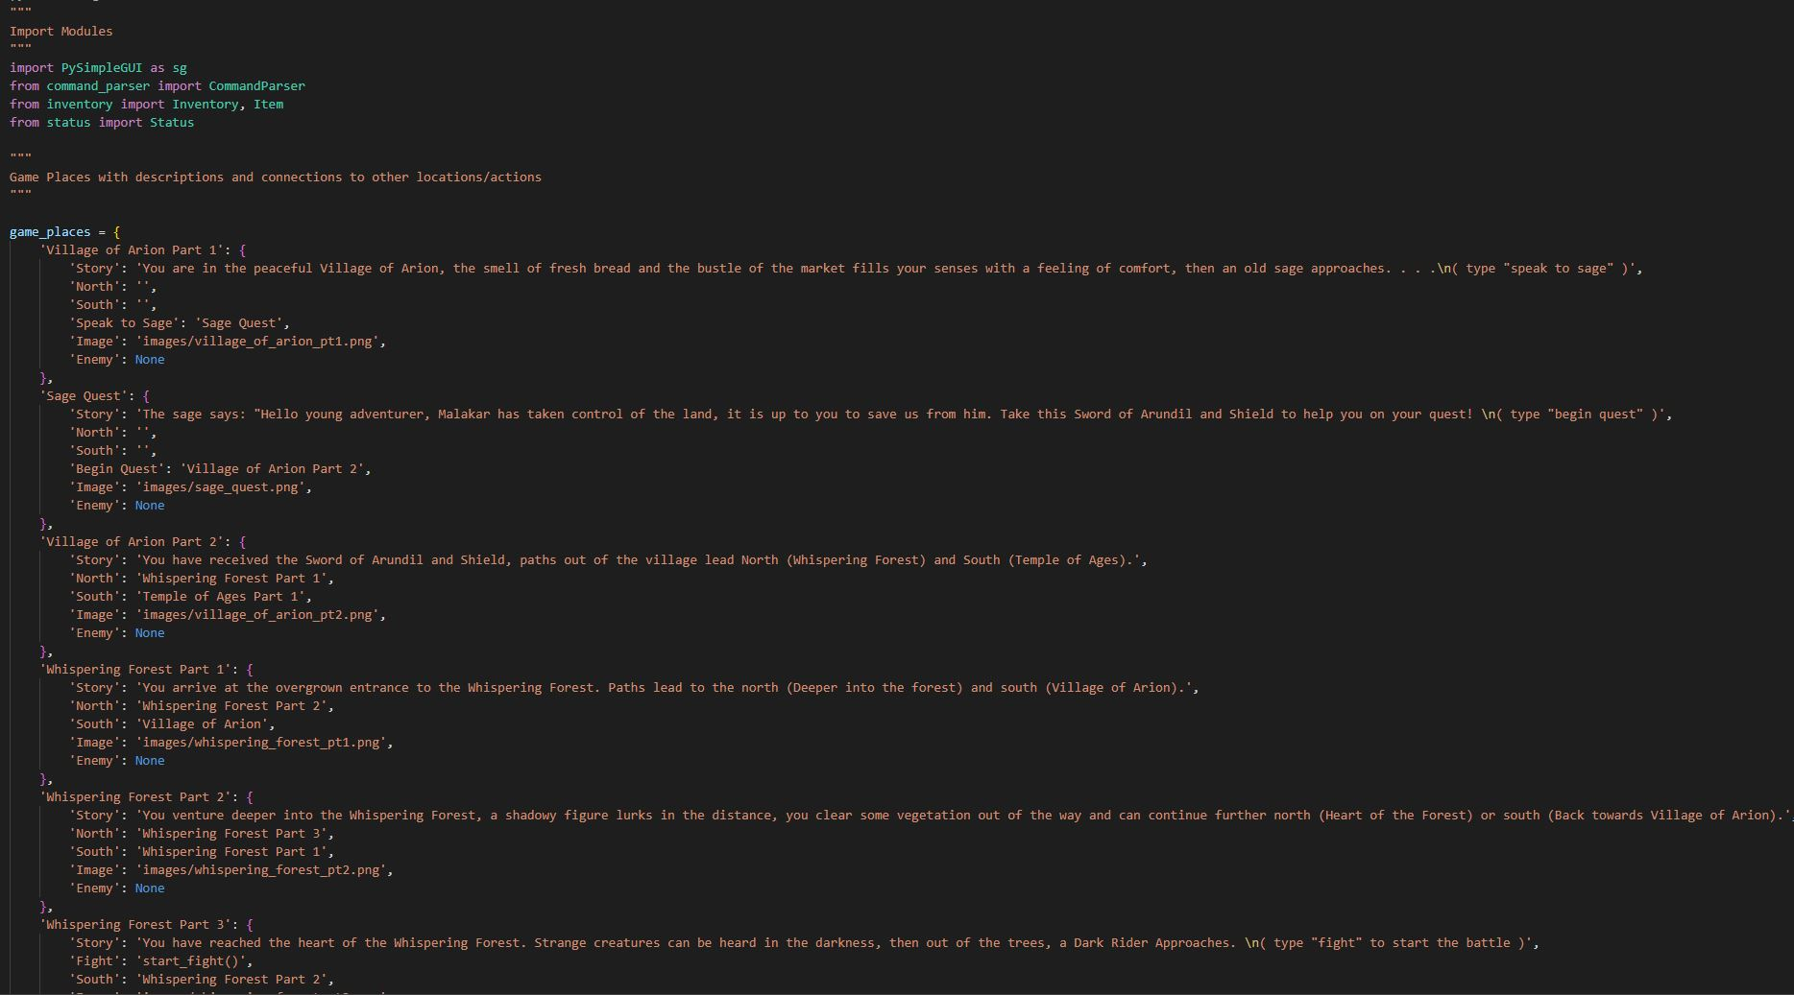

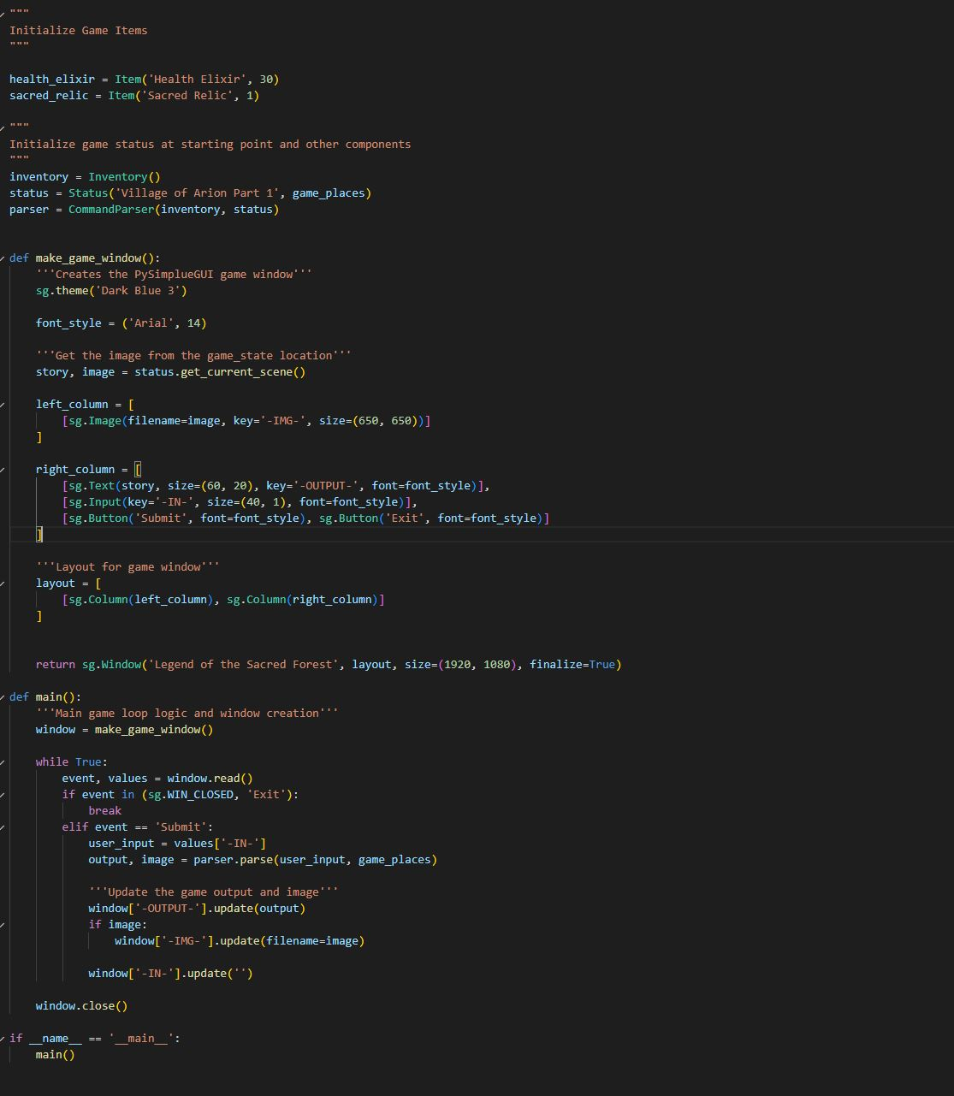

Command_parser.py

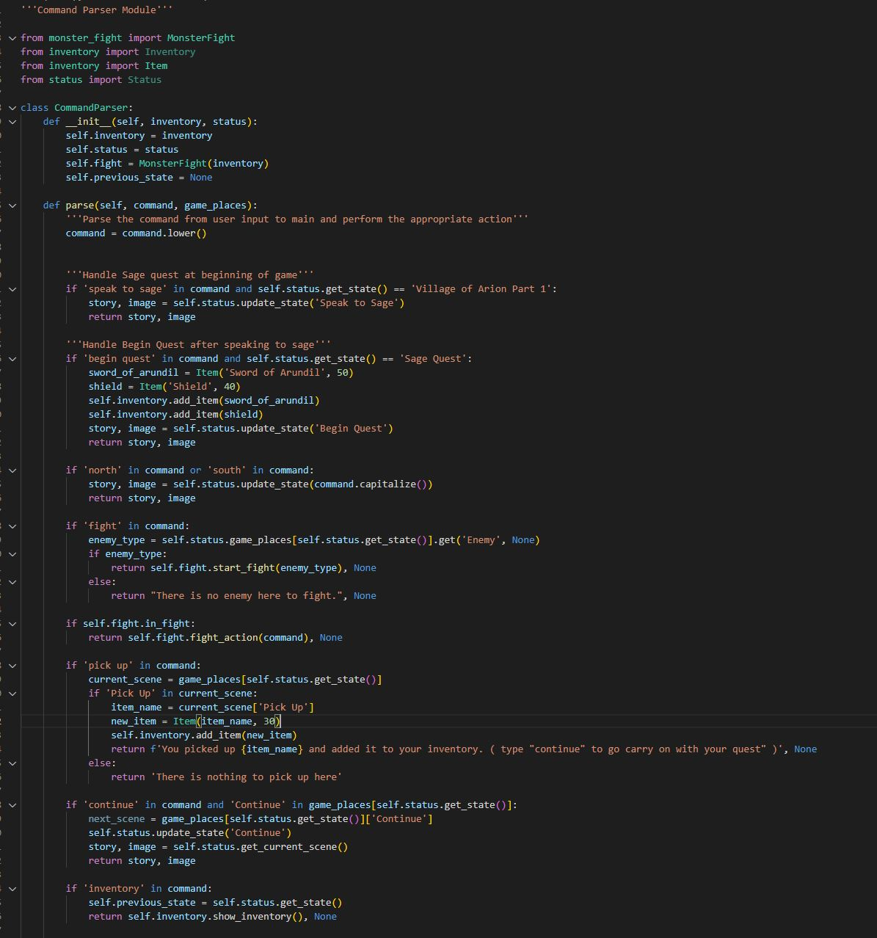

Monster_fight.py

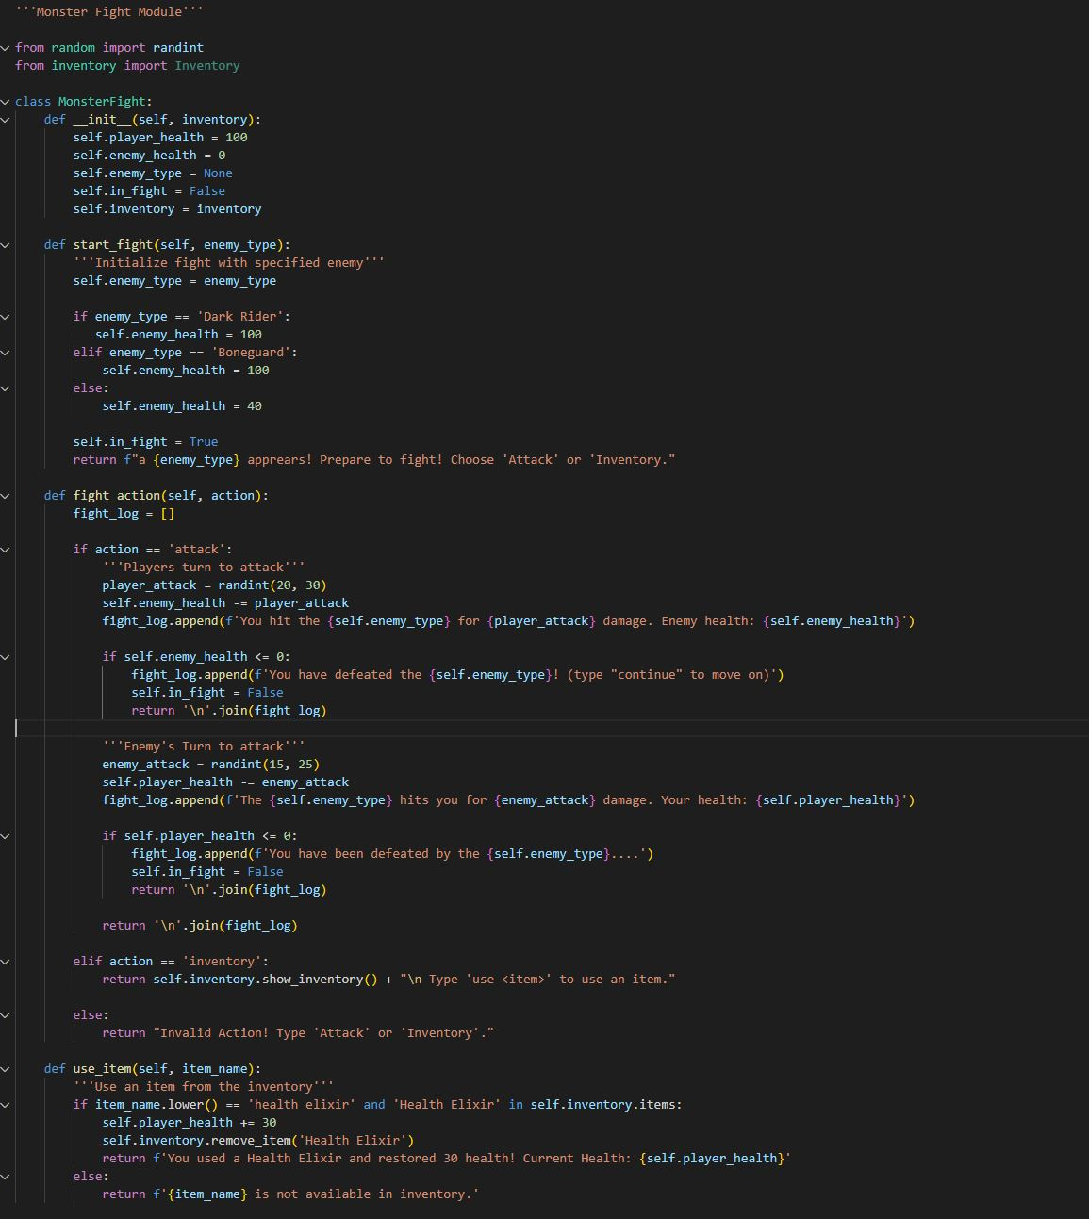

Inventory.py

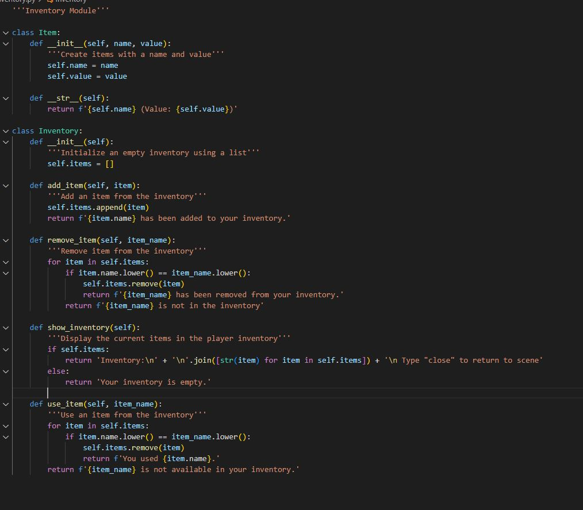

Status.py

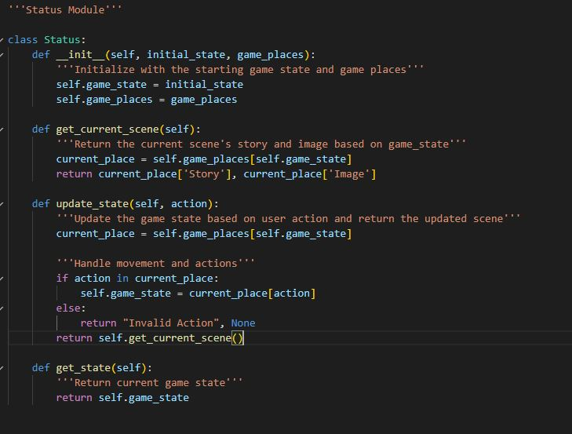

## References and citations

Guido van Rossum, Barry Warsaw, Alyssa Coghlan. 2021. Python PEP 8 – Style Guide for Python Code.

<https://peps.python.org/pep-0008/>

NMIT – Todd Cochrane. 2024. Python Simple Game example.

<https://ecampus.nmit.ac.nz/moodle/mod/folder/view.php?id=1548830>

Images for the Game:

ChatGPT – Alex Herbert. 2024. Game Images for Legend of the Sacred Forest.

<https://chatgpt.com/c/66e1014f-849c-800d-9ad8-6512f6f21e6a>